Joe Merrill 5FEB21
CMSC350 Project 2

UML Class Diagram

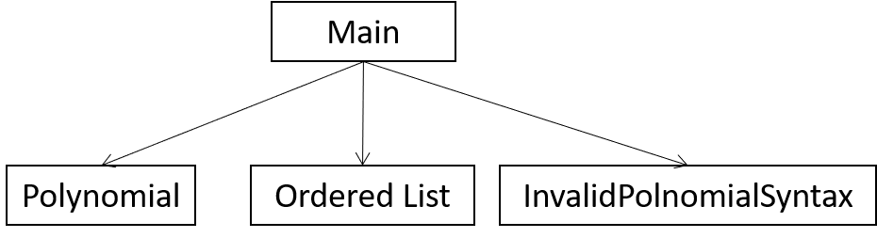

# | Input | Expected Output | Actual Output | Pass?
1 | 4.0 3 2.5 1 8.0 0  5.0 4 5.0 0  4.5 4 5.7 2 8.6 0 | 4.0x^3 + 2.5x + 8.0  5.0x^4 + 5.0  4.5x^4 + 5.7x^2 + 8.6 | 4.0x^3 + 2.5x + 8.0  5.0x^4 + 5.0  4.5x^4 + 5.7x^2 + 8.6 | YES
2 | 3.4 3 6.7 1 9.3 0  6.2 4 4.1 0  5.4 4 6.7 2 9.4 0 | 3.4x^3 + 6.7x + 9.3  6.2x^4 + 4.1  5.4x^4 + 6.7x^2 + 9.4 | 3.4x^3 + 6.7x + 9.3  6.2x^4 + 4.1  5.4x^4 + 6.7x^2 + 9.4 | YES
3 | 3.4 3 8.9 1 4.1 0  7.8 4 7.5 0  3.4 4 7.5 2 4.2 0 | 3.4x^3 + 8.9x + 4.1  7.8x^4 + 7.5  3.4x^4 + 7.5x^2 + 4.2 | 3.4x^3 + 8.9x + 4.1  7.8x^4 + 7.5  3.4x^4 + 7.5x^2 + 4.2 | YES

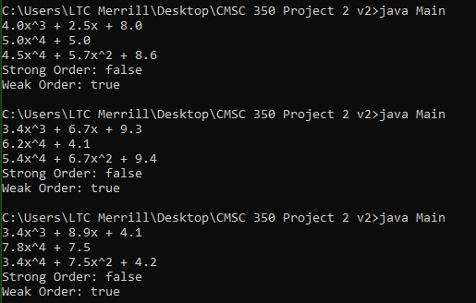

The basics of Java were easier for me this time, but organizing the project presented challenges. I wrote it all out in pseudocode first and slowly built it bit by bit. Spent a while debugging it.

